How does hash Map & Collections Differs from Java 7 & 8

In this post, we will dive deeper into JDK 8’s new strategy for dealing with HashMap collisions.
Hash collision degrades the performance of HashMap significantly. With this new approach, existing applications can expect performance improvements in case they are using HashMaps having large number of elements by simply upgrading to Java 8.
Hash collisions have negative impact on the lookup time of HashMap. When multiple keys end up in the same bucket, then values along with their keys are placed in a linked list. In case of retrieval, linked list has to be traversed to get the entry. In worst case scenario, when all keys are mapped to the same bucket, the lookup time of HashMap increases from O(1) to O(n).
Java 8 has come with the following improvements/changes of HashMap objects in case of high collisions.
- The alternative String hash function added in Java 7 has been removed.
- Buckets containing a large number of colliding keys will store their entries in a balanced tree instead of a linked list after certain threshold is reached.
Above changes ensure performance of O(log(n)) in worst case scenarios (hash function is not distributing keys properly) and O(1) with proper hashCode().
How linked list is replaced with binary tree?
In Java 8, HashMap replaces linked list with a binary tree when the number of elements in a bucket reaches certain threshold. While converting the list to binary tree, hashcode is used as a branching variable. If there are two different hashcodes in the same bucket, one is considered bigger and goes to the right of the tree and other one to the left. But when both the hashcodes are equal, HashMap assumes that the keys are comparable, and compares the key to determine the direction so that some order can be maintained. It is a good practice to make the keys of HashMap comparable.
This JDK 8 change applies only to HashMap, LinkedHashMap and ConcurrentHashMap.

Java 8 BiFunction Examples
In Java 8, BiFunction is a functional interface; it takes two arguments and returns an object.

@FunctionalInterface
public interface BiFunction<T, U, R> {

R apply(T t, U u);

}
T – Type of the first argument to the function.
U – Type of the second argument to the function.
R – Type of the result of the function.
1. BiFunction<T, U, R>
1.1 This example takes two Integers and returns an Integer, Double or List
public class Java8BiFunction1 {
public static void main(String[] args) {
// takes two Integers and return an Integer
BiFunction<Integer, Integer, Integer> func = (x1, x2) -> x1 + x2;
Integer result = func.apply(2, 3);
System.out.println(result); // 5
// take two Integers and return an Double
BiFunction<Integer, Integer, Double> func2 = (x1, x2) -> Math.pow(x1, x2);
Double result2 = func2.apply(2, 4);
System.out.println(result2); // 16.0
// take two Integers and return a List<Integer>
BiFunction<Integer, Integer, List<Integer>> func3 = (x1, x2) -> Arrays.asList(x1 + x2);
List<Integer> result3 = func3.apply(2, 3);
System.out.println(result3);
}
}
Output
5
16.0
[5]

Difference Between map() And flatMap() In Java Stream

In Java, the Stream interface has a map() and flatmap() methods and both have intermediate stream operation and return another stream as method output. Both of the functions map() and flatMap are used for transformation and mapping operations. map() function produces one output for one input value, whereas flatMap() function produces an arbitrary no of values as output (ie zero or more than zero) for each input value.
The Syntax of the map() is represented as:
<R> Stream<R> map(Function<? super T, ? extends R> mapper)
The Syntax of the flatMap() is represented as:-
<R> Stream<R> flatMap(Function<? super T, ? extends Stream<? extends R>> mapper)
Where R is the element type of the new stream. The stream is an interface and T is the type of stream elements and mapper is a stateless function that is applied to each element and the function returns the new stream.
map() can be used where we have to map the elements of a particular collection to a certain function, and then we need to return the stream which contains the updated results.

Example: Multiplying All the elements of the list by 3 and returning the updated list.
flatMap() can be used where we have to flatten or transform out the string, as we cannot flatten our string using map().
Example: Getting the 1st Character of all the String present in a List of Strings and returning the result in form of a stream.
Difference Between map() and flatmap()
map() | flatMap()
The function passed to map() operation returns a single value for a single input. | The function you pass to flatmap() operation returns an arbitrary number of values as the output.
One-to-one mapping occurs in map(). | One too many mapping occurs in flatMap().
Only perform the mapping. | Perform mapping as well as flattening.
Produce a stream of value. | Produce a stream of stream value.
map() is used only for transformation. | flatMap() is used both for transformation and mapping.
Below are the Java Programs using map() function:
- Java
// Java program using map() function
import java.io.*;
import java.util.*;
import java.util.ArrayList;
import java.util.List;
import java.util.stream.Collectors;
class GFG {

public static void main(String[] args)
{
// making the array list object
ArrayList<String> fruit = new ArrayList<>();
fruit.add("Apple");
fruit.add("mango");
fruit.add("pineapple");
fruit.add("kiwi");
System.out.println("List of fruit-" + fruit);

// lets use map() to convert list of fruit
List list = fruit.stream()
.map(s -> s.length())
.collect(Collectors.toList());
System.out.println("List generated by map-" + list);
}
}
Output:
List of fruit-[Apple, mango, pineapple, kiwi]
List generated by map-[5, 5, 9, 4]
Below is the Java Program using flatMap():
- Java
// Java program using flatMap() function
import java.io.*;
import java.util.*;
import java.util.ArrayList;
import java.util.List;
import java.util.stream.Collectors;
class GFG {
public static void main(String[] args)
{
// making the arraylist object of List of Integer
List<List<Integer> > number = new ArrayList<>();

// adding the elements to number arraylist
number.add(Arrays.asList(1, 2));
number.add(Arrays.asList(3, 4));
number.add(Arrays.asList(5, 6));
number.add(Arrays.asList(7, 8));

System.out.println("List of list-" + number);

// using flatmap() to flatten this list
List<Integer> flatList
= number.stream()
.flatMap(list -> list.stream())
.collect(Collectors.toList());

// printing the list
System.out.println("List generate by flatMap-"
+ flatList);
}
}
Output
List of list-[[1, 2], [3, 4], [5, 6], [7, 8]]
List generate by flatMap-[1, 2, 3, 4, 5, 6, 7, 8]

- Diff b/w Sequential and parallel stream?

A stream in Java is a sequence of objects which operates on a data source such as an array or a collection and supports various methods. It was introduced in Java 8’s java.util.stream package. Stream supports many aggregate operations like filter, map, limit, reduce, find, and match to customize the original data into a different form according to the need of the programmer. The operations performed on a stream do not modify its source hence a new stream is created according to the operation applied to it. The new data is a transformed copy of the original form.
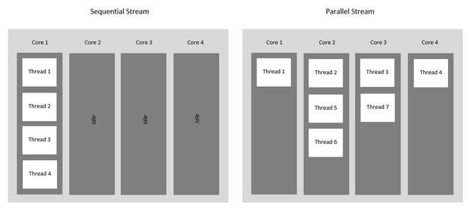

Sequential Stream
Sequential Streams are non-parallel streams that use a single thread to process the pipelining. Any stream operation without explicitly specified as parallel is treated as a sequential stream. Sequential stream’s objects are pipelined in a single stream on the same processing system hence it never takes the advantage of the multi-core system even though the underlying system supports parallel execution. Sequential stream performs operation one by one.
stream() method returns a sequential stream in Java.

Example:
- Java
filter_none
brightness_4
// Java program to understand execution
// of sequential streams

import java.io.*;
import java.util.*;
import java.util.stream.*;

class SequentialStreamDemo {

public static void main(String[] args)
{
// create a list
List<String> list = Arrays.asList( "Hello ",
"G", "E", "E", "K", "S!");

// we are using stream() method
// for sequential stream
// Iterate and print each element
// of the stream
list.stream().forEach(System.out::print);
}
}
Output
Hello GEEKS!
In this example the list.stream() works in sequence on a single thread with the print() operation and in the output of the preceding program, the content of the list is printed in an ordered sequence as this is a sequential stream.

Parallel Stream
It is a very useful feature of Java to use parallel processing, even if the whole program may not be parallelized. Parallel stream leverage multi-core processors, which increases its performance. Using parallel streams, our code gets divide into multiple streams which can be executed parallelly on separate cores of the system and the final result is shown as the combination of all the individual core’s outcomes. It is always not necessary that the whole program be parallelized, but at least some parts should be parallelized which handles the stream. The order of execution is not under our control and can give us unpredictably unordered results and like any other parallel programming, they are complex and error-prone.
- One of the simple ways to obtain a parallel stream is by invoking the parallelStream() method of Collection interface.
- Another way is to invoke the parallel() method of BaseStream interface on a sequential stream.
It is important to ensure that the result of the parallel stream is the same as is obtained through the sequential stream, so the parallel streams must be stateless, non-interfering, and associative.
Example:
// Java code to demonstrate
// ParallelStreams

class ParallelStreamExample {
public static void main(String[] args)
{
// create a list
List<String> list = Arrays.asList("Hello ",
"G", "E", "E", "K", "S!");

// using parallelStream()
// method for parallel stream
list.parallelStream().forEach(System.out::print);
}
}
Output
ES!KGEHello
Here we can see the order is not maintained as the list.parallelStream() works parallelly on multiple threads. If we run this code multiple times then we can also see that each time we are getting a different order as output but this parallel stream boosts the performance so the situation where the order is not important is the best technique to use.
Note: If we want to make each element in the parallel stream to be ordered, we can use the forEachOrdered() method, instead of the forEach() method.
Example:
// Java code to demonstrate Iterating in
// the same order via parallelStream

import java.io.*;
import java.util.*;
import java.util.stream.*;

class ParallelStreamWithOrderedIteration {

public static void main(String[] args)
{
// create a list
List<String> list
= Arrays.asList("Hello ","G", "E", "E", "K", "S!");

// using parallelStream() method for parallel stream
list.parallelStream().forEachOrdered(System.out::print);
}
}
Output
Hello GEEKS!
We can always switch between parallel and sequential very easily according to our requirements. If we want to change the parallel stream as sequential, then we should use the sequential() method specified by BaseStream Interface.
Differences between Sequential Stream and Parallel Stream
Sequential Stream | Parallel Stream
Runs on a single-core of the computer | Utilize the multiple cores of the computer.
Performance is poor | The performance is high.
Order is maintained | Doesn’t care about the order,
Only a single iteration at a time just like the for-loop. | Operates multiple iterations simultaneously in different available cores.
Each iteration waits for currently running one to finish, | Waits only if no cores are free or available at a given time,
More reliable and less error, | Less reliable and error-prone.
Platform independent, | Platform dependent

Lazy evaluation of stream

Eager loading or early loading
In eager loading, the operations are always performed before the action. Let’s take an example of a result of Exams. A student wants to search the result for a specific roll number. What if we are loading all students’ results without any input? It means we are doing eager loading.
While you are dealing with bigger data, we should not use the eager loading. Because in eager loading, we are not sure how the processed data will be used. It will always process the entire amount of data at the cost of performance.

Lazy loading or lazy processing
In lazy processing, the operations are performed after the action. It is processing the data only on demand.

How Stream is lazy?
It is an important characteristic of streams because the operation on the source data is only performed when the terminal operation is initiated. It doesn’t consume the source elements as in eager loading, the source elements are consumed only on demand.
As you have seen in Stream operations:
1. The intermediate stream doesn’t produce the result. They create a new Stream
only.
2. The terminal operation produces the result.

How intermediate operations and terminal operations work together with Lazy evaluation?
1. The intermediate operations are lazy in nature and only executed when a result of
processing is needed.
2. Intermediate operations don’t produce the result. It creates a new stream.
3. Intermediate operations are not evaluated until the terminal operations are not
initiated.
4. When a terminal operation is initiated, the traversal of streams starts, and the
the associated function is performed one by one.
import java.util.Arrays;
import java.util.List;
public class ExampleOfLazy {
public static void main(String[] args)
{
List<Integer> listOfNumber = Arrays.asList(10, 5, 6, 11, 8);
listOfNumber.stream().filter((a) -> a > 5).forEach(System.out::println);
}
}
Output: 10
6
11
8
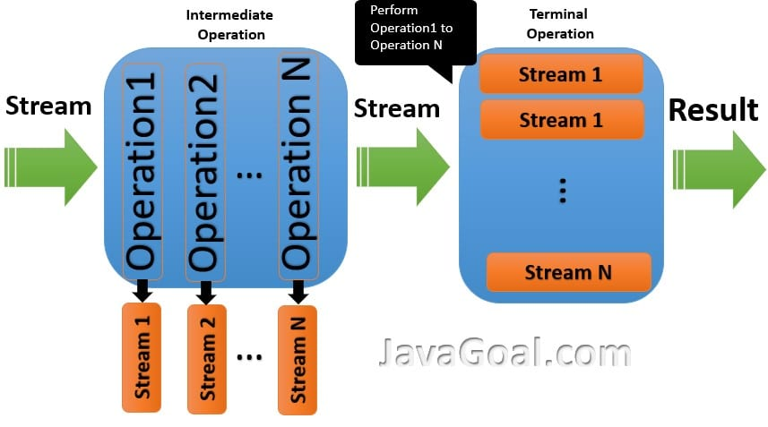
Let’s take another example of Stream. In this example, we are printing the number from the stream.
import java.util.Arrays;
import java.util.List;
import java.util.stream.Stream;
public class ExampleOfLazy
{
public static void main(String[] args)
{
List<Integer> listOfNumber = Arrays.asList(1, 2, 3, 4, 5);
Stream<Integer> stream = listOfNumber.stream();
// Calling an Intermediate operation
Stream<Integer> newStream = stream.map((number) -> printData(number));
// Calling an Terminal operation
newStream.forEach(a ->
System.out.println("Calling by Terminal operation: "+ a));
}
public static Integer printData(Object number)
{
System.out.println("Calling by Intermediate operation : "+ number);
return (Integer) number;
}
}
Output: Calling by Terminal operation: 1
Calling by Intermediate operation: 1
Calling by Terminal operation: 2
Calling by Intermediate operation: 2
Calling by Terminal operation : 3
Calling by Intermediate operation: 3
Calling by Terminal operation: 4
Calling by Intermediate operation: 4
Calling by Terminal operation: 5
Calling by Intermediate operation: 5
In this example we are using two operations: One is the intermediate operation and another is a terminal operation.

Why java lazy stream support laziness or the Advantage of laziness?
It is a very common and tricky question. So now we will discuss the role of laziness.
Let’s take the example of a shopping site. In a shopping site, you must see all products are not loaded at a time. The product loads according to user input, it doesn’t load all products with input. What if, the site is delaying the complete loading of the entire product list. If the site loads all the products, the response time would increase, and the user might get distracted.
By use of Lazy operations, you can achieve efficiency. Lazy operations are useful when input data is consumed gradually rather than having a whole complete set of elements beforehand.

- Memory changes in java 8?

MetaSpace in Java 8 with Examples
In this article, we will understand what metaspace is and how is it different from permgen.
Before understanding the metaspace, lets first understand the JVM memory structure.
JVM Memory Structure:
JVM defines various run-time data area which are used during execution of a program. Some of the areas are created by the JVM whereas some are created by the threads that are used in a program. However, the memory area created by JVM is destroyed only when the JVM exits. The data areas of thread are created during instantiation and destroyed when the thread exits. JVM Memory Structure is divided into multiple memory area like heap area, stack area, method area, PC Registers etc. The following image illustrates the different memory areas in Java:
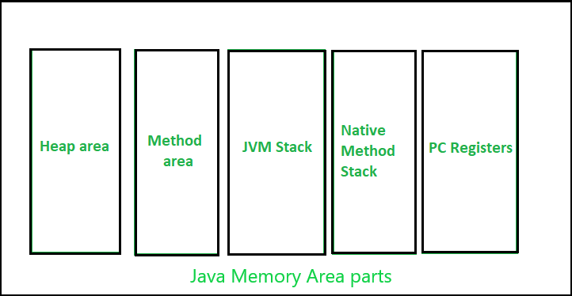
JVM Memory area parts
Here, the heap area is one of the most important memory areas of JVM. Here, all the java objects are stored. The heap is created when the JVM starts. The heap is generally divided into two parts. That is:
- Young Generation(Nursery): All the new objects are allocated in this memory. Whenever this memory gets filled, the garbage collection is performed. This is called as Minor Garbage Collection.
- Old Generation: All the long lived objects which have survived many rounds of minor garbage collection is stored in this area. Whenever this memory gets filled, the garbage collection is performed. This is called as Major Garbage Collection.
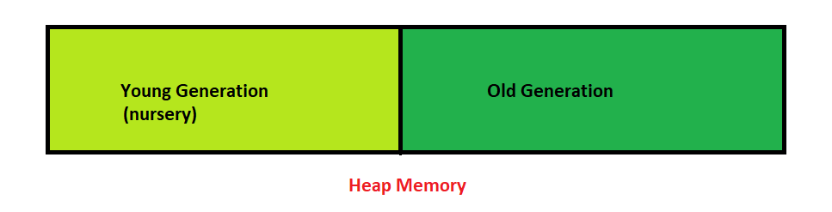

Apart from the heap memory, JVM also contains another type of memory which is called as Permanent Generation or “PermGen”.
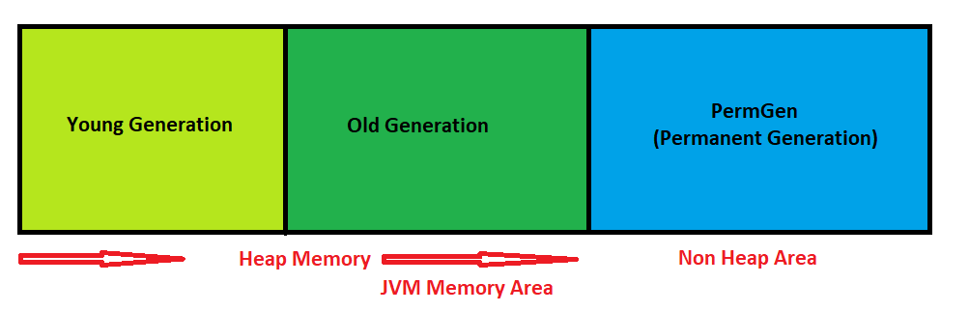
PermGen Memory: This is a special space in java heap which is separated from the main memory where all the static content is stored in this section. Apart from that, this memory also stores the application metadata required by the JVM. Metadata is a data which is used to describe the data. Here, garbage collection also happens like any other part of the memory. String pool was also part of this memory before Java 7. Method Area is a part of space in the PermGen and it is used to store the class structure and the code for methods and constructors. The biggest disadvantage of PermGen is that it contains a limited size which leads to an OutOfMemoryError. The default size of PermGen memory is 64 MB on 32-bit JVM and 82 MB on the 64-bit version. Due to this, JVM had to change the size of this memory by frequently performing Garbage collection which is a costly operation. Java also allows to manually change the size of the PermGen memory. However, the PermGen space cannot be made to auto increase. So, it is difficult to tune it. And also, the garbage collector is not efficient enough to clean the memory.
Due to the above problems, PermGen has been completely removed in Java 8. In the place of PermGen, a new feature called Meta Space has been introduced. MetaSpace grows automatically by default. Here, the garbage collection is automatically triggered when the class metadata usage reaches its maximum metaspace size.
The following table describes the difference between metaspace and PermGen:
PermGen | MetaSpace
It is removed from java 8. | It is introduced in Java 8.
PermGen always has a fixed maximum size. | Metaspace by default auto increases its size depending on the underlying OS.
Contiguous Java Heap Memory. | Native Memory(provided by underlying OS).
Ineffiecient garbage collection. | Effiecient garbage collection.

- What is Optional?

Java Optional Class : Every Java Programmer is familiar with NullPointerException. It can crash your code. And it is very hard to avoid it without using too many null checks.
Java 8 has introduced a new class Optional in java.util package. It can help in writing a neat code without using too many null checks. By using Optional, we can specify alternate values to return or alternate code to run. This makes the code more readable because the facts which were hidden are now visible to the developer.
// Java program without Optional Class
public class OptionalDemo{
public static void main(String[] args) {
String[] words = new String[10];
String word = words[5].toLowerCase();
System.out.print(word);
}
}
Output :
Exception in thread "main" java.lang.NullPointerException
To avoid abnormal termination, we use the Optional class. In the following example, we are using Optional. So, our program can execute without crashing.
The above program using Optional Class
// Java program with Optional Class
import java.util.Optional;
public class OptionalDemo{
public static void main(String[] args) {
String[] words = new String[10];
Optional<String> checkNull =
Optional.ofNullable(words[5]);
if (checkNull.isPresent()) {
String word = words[5].toLowerCase();
System.out.print(word);
} else
System.out.println("word is null");
}
}
Output :

word is null

Example 1 :
// Java program to illustrate
// optional class methods
import java.util.Optional;

class GFG {

// Driver code
public static void main(String[] args)
{

// creating a string array
String[] str = new String[5];

// Setting value for 2nd index
str[2] = "Geeks Classes are coming soon";

// It returns an empty instance of Optional class
Optional<String> empty = Optional.empty();
System.out.println(empty);

// It returns a non-empty Optional
Optional<String> value = Optional.of(str[2]);
System.out.println(value);
}
}
Output :
Optional.empty
Optional[Geeks Classes are coming soon]
Example 2 :
// Java program to illustrate
// optional class methods
import java.util.Optional;

class GFG {

// Driver code
public static void main(String[] args)
{

// creating a string array
String[] str = new String[5];

// Setting value for 2nd index
str[2] = "Geeks Classes are coming soon";

// It returns a non-empty Optional
Optional<String> value = Optional.of(str[2]);

// It returns value of an Optional.
// If value is not present, it throws
// an NoSuchElementException
System.out.println(value.get());

// It returns hashCode of the value
System.out.println(value.hashCode());

// It returns true if value is present,
// otherwise false
System.out.println(value.isPresent());
}
}
Output :
Geeks Classes are coming soon
1967487235
true

Java 8 Predicate Examples

By mkyong | Last updated: February 11, 2020
Viewed: 41,171 | +985 pv/w
In Java 8, Predicate is a functional interface, which accepts an argument and returns a boolean. Usually, it used to apply in a filter for a collection of objects.

@FunctionalInterface
public interface Predicate<T> {
boolean test(T t);
}
Further Reading
Java 8 BiPredicate Examples
1. Predicate in filter()
filter() accepts predicate as argument.
Java8Predicate.java

package com.mkyong.java8;

import java.util.Arrays;
import java.util.List;
import java.util.stream.Collectors;

public class Java8Predicate {

public static void main(String[] args) {

List<Integer> list = Arrays.asList(1, 2, 3, 4, 5, 6, 7, 8, 9, 10);

List<Integer> collect = list.stream().filter(x -> x > 5).collect(Collectors.toList());

System.out.println(collect); // [6, 7, 8, 9, 10]

}

}
Output

[6, 7, 8, 9, 10]
Java8Predicate.java

package com.mkyong.java8;

import java.util.Arrays;
import java.util.List;
import java.util.function.Predicate;
import java.util.stream.Collectors;

public class Java8Predicate {

public static void main(String[] args) {

Predicate<Integer> noGreaterThan5 = x -> x > 5;

List<Integer> list = Arrays.asList(1, 2, 3, 4, 5, 6, 7, 8, 9, 10);

List<Integer> collect = list.stream()
.filter(noGreaterThan5)
.collect(Collectors.toList());

System.out.println(collect); // [6, 7, 8, 9, 10]

}

}
Output

[6, 7, 8, 9, 10]

2. Predicate.and()
2.1 Multiple filters.
Java8Predicate2.java

package com.mkyong.java8;

import java.util.Arrays;
import java.util.List;
import java.util.stream.Collectors;

public class Java8Predicate2 {

public static void main(String[] args) {

List<Integer> list = Arrays.asList(1, 2, 3, 4, 5, 6, 7, 8, 9, 10);

// multiple filters
List<Integer> collect = list.stream()
.filter(x -> x > 5 && x < 8).collect(Collectors.toList());

System.out.println(collect);

}

}
Output

[6, 7]
2.1 Replace with Predicate.and()
Java8Predicate2.java

package com.mkyong.java8;

import java.util.Arrays;
import java.util.List;
import java.util.function.Predicate;
import java.util.stream.Collectors;

public class Java8Predicate2 {

public static void main(String[] args) {

Predicate<Integer> noGreaterThan5 = x -> x > 5;
Predicate<Integer> noLessThan8 = x -> x < 8;

List<Integer> list = Arrays.asList(1, 2, 3, 4, 5, 6, 7, 8, 9, 10);

List<Integer> collect = list.stream()
.filter(noGreaterThan5.and(noLessThan8))
.collect(Collectors.toList());

System.out.println(collect);

}

}
Output

[6, 7]
3. Predicate.or()
Java8Predicate3.java

package com.mkyong.java8;

import java.util.Arrays;
import java.util.List;
import java.util.function.Predicate;
import java.util.stream.Collectors;

public class Java8Predicate3 {

public static void main(String[] args) {

Predicate<String> lengthIs3 = x -> x.length() == 3;
Predicate<String> startWithA = x -> x.startsWith("A");

List<String> list = Arrays.asList("A", "AA", "AAA", "B", "BB", "BBB");

List<String> collect = list.stream()
.filter(lengthIs3.or(startWithA))
.collect(Collectors.toList());

System.out.println(collect);

}

}
Output

[A, AA, AAA, BBB]
4. Predicate.negate()
Find all elements not start with ‘A’.
Java8Predicate4.java

package com.mkyong.java8;

import java.util.Arrays;
import java.util.List;
import java.util.function.Predicate;
import java.util.stream.Collectors;

public class Java8Predicate4 {

public static void main(String[] args) {

Predicate<String> startWithA = x -> x.startsWith("A");

List<String> list = Arrays.asList("A", "AA", "AAA", "B", "BB", "BBB");

List<String> collect = list.stream()
.filter(startWithA.negate())
.collect(Collectors.toList());

System.out.println(collect);

}

}
Output

[B, BB, BBB]
5. Predicate.test() in function
Predicate in function.
Java8Predicate5.java

package com.mkyong.java8;

import java.util.Arrays;
import java.util.List;
import java.util.function.Predicate;
import java.util.stream.Collectors;

public class Java8Predicate5 {

public static void main(String[] args) {

List<String> list = Arrays.asList("A", "AA", "AAA", "B", "BB", "BBB");

System.out.println(StringProcessor.filter(
list, x -> x.startsWith("A"))); // [A, AA, AAA]

System.out.println(StringProcessor.filter(
list, x -> x.startsWith("A") && x.length() == 3)); // [AAA]

}

}

class StringProcessor {
static List<String> filter(List<String> list, Predicate<String> predicate) {
return list.stream().filter(predicate::test).collect(Collectors.toList());
}
}
Output

[A, AA, AAA]
[AAA]

Static method in Interface in Java
- Difficulty Level : Easy
- Last Updated : 16 Oct, 2020
Static Methods in Interface are those methods, which are defined in the interface with the keyword static. Unlike other methods in Interface, these static methods contain the complete definition of the function and since the definition is complete and the method is static, therefore these methods cannot be overridden or changed in the implementation class.
Similar to Default Method in Interface, the static method in an interface can be defined in the interface, but cannot be overridden in Implementation Classes. To use a static method, Interface name should be instantiated with it, as it is a part of the Interface only.
Below programs illustrate static methods in interfaces:
Program 1: To demonstrate use of Static method in Interface.
In this program, a simple static method is defined and declared in an interface which is being called in the main() method of the Implementation Class InterfaceDemo. Unlike the default method, the static method defines in Interface hello(), cannot be overridden in implementing the class.

// Java program to demonstrate
// static method in Interface.

interface NewInterface {

// static method
static void hello()
{
System.out.println("Hello, New Static Method Here");
}

// Public and abstract method of Interface
void overrideMethod(String str);
}

// Implementation Class
public class InterfaceDemo implements NewInterface {

public static void main(String[] args)
{
InterfaceDemo interfaceDemo = new InterfaceDemo();

// Calling the static method of interface
NewInterface.hello();

// Calling the abstract method of interface
interfaceDemo.overrideMethod("Hello, Override Method here");
}

// Implementing interface method

@Override
public void overrideMethod(String str)
{
System.out.println(str);
}
}
Output:
Hello, New Static Method Here
Hello, Override Method here
Program 2: To demonstrate Scope of Static method.
In this program, the scope of the static method definition is within the interface only. If same name method is implemented in the implementation class then that method becomes a static member of that respective class.
// Java program to demonstrate scope
// of static method in Interface.

interface PrintDemo {

// Static Method
static void hello()
{
System.out.println("Called from Interface PrintDemo");
}
}

public class InterfaceDemo implements PrintDemo {

public static void main(String[] args)
{

// Call Interface method as Interface
// name is preceeding with method
PrintDemo.hello();

// Call Class static method
hello();
}

// Class Static method is defined
static void hello()
{
System.out.println("Called from Class");
}
}
Output:
Called from Interface PrintDemo
Called from Class

Default Methods In Java 8
- Difficulty Level : Medium
- Last Updated : 17 Feb, 2020
Before Java 8, interfaces could have only abstract methods. The implementation of these methods has to be provided in a separate class. So, if a new method is to be added in an interface, then its implementation code has to be provided in the class implementing the same interface. To overcome this issue, Java 8 has introduced the concept of default methods which allow the interfaces to have methods with implementation without affecting the classes that implement the interface.
// A simple program to Test Interface default
// methods in java
interface TestInterface
{
// abstract method
public void square(int a);

// default method
default void show()
{
System.out.println("Default Method Executed");
}
}

class TestClass implements TestInterface
{
// implementation of square abstract method
public void square(int a)
{
System.out.println(a*a);
}

public static void main(String args[])
{
TestClass d = new TestClass();
d.square(4);

// default method executed
d.show();
}
}
Output:
16
Default Method Executed
The default methods were introduced to provide backward compatibility so that existing interfaces can use the lambda expressions without implementing the methods in the implementation class. Default methods are also known as defender methods or virtual extension methods.
Static Methods:
The interfaces can have static methods as well which is similar to static method of classes.
// A simple Java program to TestClassnstrate static
// methods in java
interface TestInterface
{
// abstract method
public void square (int a);

// static method
static void show()
{
System.out.println("Static Method Executed");
}
}

class TestClass implements TestInterface
{
// Implementation of square abstract method
public void square (int a)
{
System.out.println(a*a);
}

public static void main(String args[])
{
TestClass d = new TestClass();
d.square(4);

// Static method executed
TestInterface.show();
}
}
Output:

16
Static Method Executed
Default Methods and Multiple Inheritance
In case both the implemented interfaces contain default methods with same method signature, the implementing class should explicitly specify which default method is to be used or it should override the default method.
// A simple Java program to demonstrate multiple
// inheritance through default methods.
interface TestInterface1
{
// default method
default void show()
{
System.out.println("Default TestInterface1");
}
}

interface TestInterface2
{
// Default method
default void show()
{
System.out.println("Default TestInterface2");
}
}

// Implementation class code
class TestClass implements TestInterface1, TestInterface2
{
// Overriding default show method
public void show()
{
// use super keyword to call the show
// method of TestInterface1 interface
TestInterface1.super.show();

// use super keyword to call the show
// method of TestInterface2 interface
TestInterface2.super.show();
}

public static void main(String args[])
{
TestClass d = new TestClass();
d.show();
}
}
Output:
Default TestInterface1
Default TestInterface2
Important Points:
- Interfaces can have default methods with implementation in Java 8 on later.
- Interfaces can have static methods as well, similar to static methods in classes.
- Default methods were introduced to provide backward compatibility for old interfaces so that they can have new methods without affecting existing code.

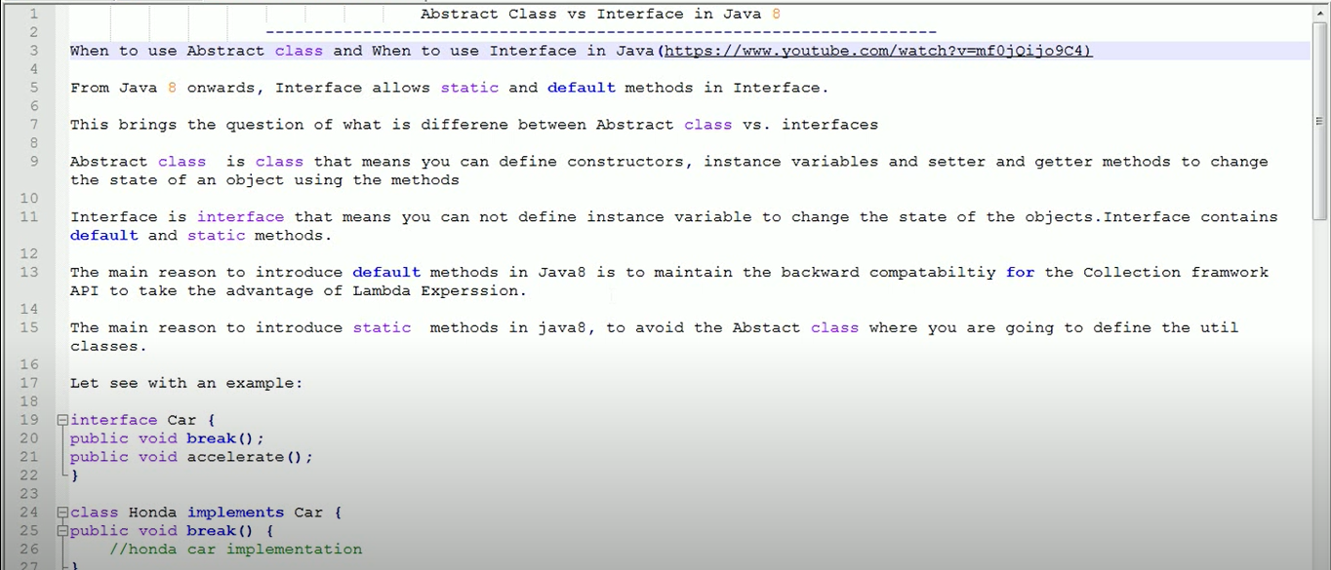

Exception Handling in Java Streams

myList.stream()
.map(item -> {
try {
return doSomething(item);
} catch (MyException e) {
throw new RuntimeException(e);
}
})
.forEach(System.out::println);
----------------

myList.stream()
.map(this::trySomething)
.forEach(System.out::println);

private Item trySomething(Item item) {
try {
return doSomething(item);
} catch (MyException e) {
throw new RuntimeException(e);
}
}

Java Lambda Expressions
Lambda expression is a new and important feature of Java which was included in Java SE 8. It provides a clear and concise way to represent one method interface using an expression. It is very useful in collection library. It helps to iterate, filter and extract data from collection.
The Lambda expression is used to provide the implementation of an interface which has functional interface. It saves a lot of code. In case of lambda expression, we don't need to define the method again for providing the implementation. Here, we just write the implementation code.
Java lambda expression is treated as a function, so compiler does not create .class file.

Functional Interface
Lambda expression provides implementation of functional interface. An interface which has only one abstract method is called functional interface. Java provides an anotation @FunctionalInterface, which is used to declare an interface as functional interface.

Why use Lambda Expression
- To provide the implementation of Functional interface.
- Less coding.

Java Lambda Expression Syntax
- (argument-list) -> {body}
Java lambda expression is consisted of three components.
1) Argument-list: It can be empty or non-empty as well.
2) Arrow-token: It is used to link arguments-list and body of expression.
3) Body: It contains expressions and statements for lambda expression.
No Parameter Syntax
- () -> {
- //Body of no parameter lambda
- }
One Parameter Syntax
- (p1) -> {
- //Body of single parameter lambda
- }
Two Parameter Syntax
- (p1,p2) -> {
- //Body of multiple parameter lambda
- }
Let's see a scenario where we are not implementing Java lambda expression. Here, we are implementing an interface without using lambda expression.

Without Lambda Expression
- interface Drawable{
- public void draw();
- }
- public class LambdaExpressionExample {
- public static void main(String[] args) {
- int width=10;

- //without lambda, Drawable implementation using anonymous class
- Drawable d=new Drawable(){
- public void draw(){System.out.println("Drawing "+width);}
- };
- d.draw();
- }
- }
Test it Now
Output:
Drawing 10

Java Lambda Expression Example
Now, we are going to implement the above example with the help of Java lambda expression.
- @FunctionalInterface //It is optional
- interface Drawable{
- public void draw();
- }

- public class LambdaExpressionExample2 {
- public static void main(String[] args) {
- int width=10;

- //with lambda
- Drawable d2=()->{
- System.out.println("Drawing "+width);
- };
- d2.draw();
- }
- }
Test it Now
Output:
Drawing 10

A lambda expression can have zero or any number of arguments. Let's see the examples:

Java Lambda Expression Example: No Parameter
- interface Sayable{
- public String say();
- }
- public class LambdaExpressionExample3{
- public static void main(String[] args) {
- Sayable s=()->{
- return "I have nothing to say.";
- };
- System.out.println(s.say());
- }
- }
Test it Now
Output:
I have nothing to say.

Java Lambda Expression Example: Single Parameter
- interface Sayable{
- public String say(String name);
- }

- public class LambdaExpressionExample4{
- public static void main(String[] args) {

- // Lambda expression with single parameter.
- Sayable s1=(name)->{
- return "Hello, "+name;
- };
- System.out.println(s1.say("Sonoo"));

- // You can omit function parentheses
- Sayable s2= name ->{
- return "Hello, "+name;
- };
- System.out.println(s2.say("Sonoo"));
- }
- }
Test it Now
Output:
Hello, Sonoo
Hello, Sonoo

Java Lambda Expression Example: Multiple Parameters
- interface Addable{
- int add(int a,int b);
- }

- public class LambdaExpressionExample5{
- public static void main(String[] args) {

- // Multiple parameters in lambda expression
- Addable ad1=(a,b)->(a+b);
- System.out.println(ad1.add(10,20));

- // Multiple parameters with data type in lambda expression
- Addable ad2=(int a,int b)->(a+b);
- System.out.println(ad2.add(100,200));
- }
- }
Test it Now
Output:
30
300

Java Lambda Expression Example: with or without return keyword
In Java lambda expression, if there is only one statement, you may or may not use return keyword. You must use return keyword when lambda expression contains multiple statements.
- interface Addable{
- int add(int a,int b);
- }

- public class LambdaExpressionExample6 {
- public static void main(String[] args) {

- // Lambda expression without return keyword.
- Addable ad1=(a,b)->(a+b);
- System.out.println(ad1.add(10,20));

- // Lambda expression with return keyword.
- Addable ad2=(int a,int b)->{
- return (a+b);
- };
- System.out.println(ad2.add(100,200));
- }
- }
Test it Now
Output:
30
300

Java Lambda Expression Example: Foreach Loop
- import java.util.*;
- public class LambdaExpressionExample7{
- public static void main(String[] args) {

- List<String> list=new ArrayList<String>();
- list.add("ankit");
- list.add("mayank");
- list.add("irfan");
- list.add("jai");

- list.forEach(
- (n)->System.out.println(n)
- );
- }
- }
Test it Now
Output:
ankit
mayank
irfan
jai

Java Lambda Expression Example: Multiple Statements
- @FunctionalInterface
- interface Sayable{
- String say(String message);
- }

- public class LambdaExpressionExample8{
- public static void main(String[] args) {

- // You can pass multiple statements in lambda expression
- Sayable person = (message)-> {
- String str1 = "I would like to say, ";
- String str2 = str1 + message;
- return str2;
- };
- System.out.println(person.say("time is precious."));
- }
- }
Test it Now
Output:
I would like to say, time is precious.

Java Lambda Expression Example: Creating Thread
You can use lambda expression to run thread. In the following example, we are implementing run method by using lambda expression.
- public class LambdaExpressionExample9{
- public static void main(String[] args) {

- //Thread Example without lambda
- Runnable r1=new Runnable(){
- public void run(){
- System.out.println("Thread1 is running...");
- }
- };
- Thread t1=new Thread(r1);
- t1.start();
- //Thread Example with lambda
- Runnable r2=()->{
- System.out.println("Thread2 is running...");
- };
- Thread t2=new Thread(r2);
- t2.start();
- }
- }
Test it Now
Output:
Thread1 is running...
Thread2 is running...

Java lambda expression can be used in the collection framework. It provides efficient and concise way to iterate, filter and fetch data. Following are some lambda and collection examples provided.

Java Lambda Expression Example: Comparator
- import java.util.ArrayList;
- import java.util.Collections;
- import java.util.List;
- class Product{
- int id;
- String name;
- float price;
- public Product(int id, String name, float price) {
- super();
- this.id = id;
- this.name = name;
- this.price = price;
- }
- }
- public class LambdaExpressionExample10{
- public static void main(String[] args) {
- List<Product> list=new ArrayList<Product>();

- //Adding Products
- list.add(new Product(1,"HP Laptop",25000f));
- list.add(new Product(3,"Keyboard",300f));
- list.add(new Product(2,"Dell Mouse",150f));

- System.out.println("Sorting on the basis of name...");

- // implementing lambda expression
- Collections.sort(list,(p1,p2)->{
- return p1.name.compareTo(p2.name);
- });
- for(Product p:list){
- System.out.println(p.id+" "+p.name+" "+p.price);
- }

- }
- }
Test it Now
Output:
Sorting on the basis of name...
2 Dell Mouse 150.0
1 HP Laptop 25000.0
3 Keyboard 300.0

Java Lambda Expression Example: Filter Collection Data
- import java.util.ArrayList;
- import java.util.List;
- import java.util.stream.Stream;
- class Product{
- int id;
- String name;
- float price;
- public Product(int id, String name, float price) {
- super();
- this.id = id;
- this.name = name;
- this.price = price;
- }
- }
- public class LambdaExpressionExample11{
- public static void main(String[] args) {
- List<Product> list=new ArrayList<Product>();
- list.add(new Product(1,"Samsung A5",17000f));
- list.add(new Product(3,"Iphone 6S",65000f));
- list.add(new Product(2,"Sony Xperia",25000f));
- list.add(new Product(4,"Nokia Lumia",15000f));
- list.add(new Product(5,"Redmi4 ",26000f));
- list.add(new Product(6,"Lenevo Vibe",19000f));

- // using lambda to filter data
- Stream<Product> filtered_data = list.stream().filter(p -> p.price > 20000);

- // using lambda to iterate through collection
- filtered_data.forEach(
- product -> System.out.println(product.name+": "+product.price)
- );
- }
- }
Test it Now
Output:
Iphone 6S: 65000.0
Sony Xperia: 25000.0
Redmi4 : 26000.0

Difference Between map() and flatMap() in Java
In this post, we will discuss the difference between map() and flatMap() methods of Stream class in Java.

1. Signature
The prototype of Stream.map() is:
/**
* @param The element type of the new stream
* @param mapper a non-interfering, stateless function to apply to each element
* @return the new stream
*/
<R> Stream<R> map(Function<? super T, ? extends R> mapper);
The prototype of Stream.flatMap() is:
/**
* @param The element type of the new stream
* @param mapper a non-interfering, stateless function to apply to each
* element which produces a stream of new values
* @return the new stream
*/
<R> Stream<R> flatMap(Function<? super T, ? extends Stream<? extends R>> mapper);

2. Definition
Both map() and flatMap() takes a mapping function which is applied to each element of a Stream<T>, and returns a Stream<R>. The only difference is that the mapping function in the case of flatMap() produces a stream of new values, whereas for map() it produces a single value for each input element.
Arrays.stream(), List.stream(), etc, are commonly used mapping function for flatMap(). Since the mapping function for flatMap() returns another stream, we should get a stream of streams. However, flatMap() has the effect of replacing each generated stream by the contents of that stream. In other words, all the separate streams that are generated by the function get flattened into one single stream.[1]

3. How to use map()
Since map() produce a Stream consisting of the results of applying the given function to the elements of the input Stream, it is often used for converting Stream of one type to Stream of another type. For instance, here’s how we can convert List of Character to List of Integer (assuming valid input).
1  2  3 | Stream.of('1', '2', '3') // Stream<Character>  .map(String::valueOf) // Stream<String>  .map(Integer::parseInt); // Stream<Integer>
Above code can be further shortened with lambdas as shown below:
1  2 | Stream.of('1', '2', '3') // Stream<Character>  .map(ch -> Integer.parseInt(ch.toString())); // Stream<Integer>
Here’s how we can convert List of Integer to a List of Character.
1  2  3 | Arrays.asList(1, 2, 3).stream() // Stream<Integer>  .map(String::valueOf) // Stream<String>  .map(s -> s.charAt(0)); // Stream<Character>
This can also be done with a single call to map() function as shown below:
1  2 | Arrays.asList(1, 2, 3).stream() // Stream<Integer>  .map(s -> String.valueOf(s).charAt(0)); // Stream<Character>

4. Why do we need flatMap()?
Suppose we have a List of List<Integers> and we need a single List of Integer containing elements of all the member lists. This can be done as follows:
1  2  3  4  5  6  7  8  9  10  11  12  13  14  15  16  17  18  19  20  21  22  23  24 | import java.util.Arrays;  import java.util.List;  import java.util.stream.Collectors;  // Program to demonstrate flatMap() method in Java 8 and above  class Main  {  public static void main(String[] args)  {  List<Integer> a = Arrays.asList(1, 2, 3);  List<Integer> b = Arrays.asList(4, 5);  List<Integer> c = Arrays.asList(6, 7, 8);  List<List<Integer>> listOfListofInts = Arrays.asList(a, b, c);  System.out.println("Before flattening : " + listOfListofInts);  List<Integer> listofInts = listOfListofInts.stream()  .flatMap(list -> list.stream())  .collect(Collectors.toList());  System.out.println("After flattening : " + listofInts);  }  }
Download Run Code
Output:
Before flattening : [[1, 2, 3], [4, 5], [6, 7, 8]]
After flattening : [1, 2, 3, 4, 5, 6, 7, 8]

Java Functional Interfaces
An Interface that contains exactly one abstract method is known as functional interface. It can have any number of default, static methods but can contain only one abstract method. It can also declare methods of object class.
Functional Interface is also known as Single Abstract Method Interfaces or SAM Interfaces. It is a new feature in Java, which helps to achieve functional programming approach.

Example 1
- @FunctionalInterface
- interface sayable{
- void say(String msg);
- }
- public class FunctionalInterfaceExample implements sayable{
- public void say(String msg){
- System.out.println(msg);
- }
- public static void main(String[] args) {
- FunctionalInterfaceExample fie = new FunctionalInterfaceExample();
- fie.say("Hello there");
- }
- }
Test it Now
Output:
Hello there

A functional interface can have methods of object class. See in the following example.

Example 2

- @FunctionalInterface
- interface sayable{
- void say(String msg); // abstract method
- // It can contain any number of Object class methods.
- int hashCode();
- String toString();
- boolean equals(Object obj);
- }
- public class FunctionalInterfaceExample2 implements sayable{
- public void say(String msg){
- System.out.println(msg);
- }
- public static void main(String[] args) {
- FunctionalInterfaceExample2 fie = new FunctionalInterfaceExample2();
- fie.say("Hello there");
- }
- }
Test it Now
Output:
Hello there

Invalid Functional Interface
A functional interface can extends another interface only when it does not have any abstract method.
- interface sayable{
- void say(String msg); // abstract method
- }
- @FunctionalInterface
- interface Doable extends sayable{
- // Invalid '@FunctionalInterface' annotation; Doable is not a functional interface
- void doIt();
- }
Output:
compile-time error

Example 3
In the following example, a functional interface is extending to a non-functional interface.
- interface Doable{
- default void doIt(){
- System.out.println("Do it now");
- }
- }
- @FunctionalInterface
- interface Sayable extends Doable{
- void say(String msg); // abstract method
- }
- public class FunctionalInterfaceExample3 implements Sayable{
- public void say(String msg){
- System.out.println(msg);
- }
- public static void main(String[] args) {
- FunctionalInterfaceExample3 fie = new FunctionalInterfaceExample3();
- fie.say("Hello there");
- fie.doIt();
- }
- }
Test it Now
Output:
Hello there
Do it now

Java Predefined-Functional Interfaces
Java provides predefined functional interfaces to deal with functional programming by using lambda and method references.
You can also define your own custom functional interface. Following is the list of functional interface which are placed in java.util.function package.

Interface | Description
BiConsumer<T,U> | It represents an operation that accepts two input arguments and returns no result.
Consumer<T> | It represents an operation that accepts a single argument and returns no result.
Function<T,R> | It represents a function that accepts one argument and returns a result.
Predicate<T> | It represents a predicate (boolean-valued function) of one argument.
BiFunction<T,U,R> | It represents a function that accepts two arguments and returns a a result.
BinaryOperator<T> | It represents an operation upon two operands of the same data type. It returns a result of the same type as the operands.
BiPredicate<T,U> | It represents a predicate (boolean-valued function) of two arguments.
BooleanSupplier | It represents a supplier of boolean-valued results.
DoubleBinaryOperator | It represents an operation upon two double type operands and returns a double type value.
DoubleConsumer | It represents an operation that accepts a single double type argument and returns no result.
DoubleFunction<R> | It represents a function that accepts a double type argument and produces a result.
DoublePredicate | It represents a predicate (boolean-valued function) of one double type argument.
DoubleSupplier | It represents a supplier of double type results.
DoubleToIntFunction | It represents a function that accepts a double type argument and produces an int type result.
DoubleToLongFunction | It represents a function that accepts a double type argument and produces a long type result.
DoubleUnaryOperator | It represents an operation on a single double type operand that produces a double type result.
IntBinaryOperator | It represents an operation upon two int type operands and returns an int type result.
IntConsumer | It represents an operation that accepts a single integer argument and returns no result.
IntFunction<R> | It represents a function that accepts an integer argument and returns a result.
IntPredicate | It represents a predicate (boolean-valued function) of one integer argument.
IntSupplier | It represents a supplier of integer type.
IntToDoubleFunction | It represents a function that accepts an integer argument and returns a double.
IntToLongFunction | It represents a function that accepts an integer argument and returns a long.
IntUnaryOperator | It represents an operation on a single integer operand that produces an integer result.
LongBinaryOperator | It represents an operation upon two long type operands and returns a long type result.
LongConsumer | It represents an operation that accepts a single long type argument and returns no result.
LongFunction<R> | It represents a function that accepts a long type argument and returns a result.
LongPredicate | It represents a predicate (boolean-valued function) of one long type argument.
LongSupplier | It represents a supplier of long type results.
LongToDoubleFunction | It represents a function that accepts a long type argument and returns a result of double type.
LongToIntFunction | It represents a function that accepts a long type argument and returns an integer result.
LongUnaryOperator | It represents an operation on a single long type operand that returns a long type result.
ObjDoubleConsumer<T> | It represents an operation that accepts an object and a double argument, and returns no result.
ObjIntConsumer<T> | It represents an operation that accepts an object and an integer argument. It does not return result.
ObjLongConsumer<T> | It represents an operation that accepts an object and a long argument, it returns no result.
Supplier<T> | It represents a supplier of results.
ToDoubleBiFunction<T,U> | It represents a function that accepts two arguments and produces a double type result.
ToDoubleFunction<T> | It represents a function that returns a double type result.
ToIntBiFunction<T,U> | It represents a function that accepts two arguments and returns an integer.
ToIntFunction<T> | It represents a function that returns an integer.
ToLongBiFunction<T,U> | It represents a function that accepts two arguments and returns a result of long type.
ToLongFunction<T> | It represents a function that returns a result of long type.
UnaryOperator<T> | It represents an operation on a single operand that returnsa a result of the same type as its operand.

